# CS 255 System Design Document Template

This template lays out all the different sections that you need to complete for Project Two. Each section has guidance to prompt your thinking. You will need to continually reference the interview transcript as you work to make sure that you are addressing your client’s needs. There is no required length for the final document. Instead the goal is to complete each section based on what your client’s needs are. Remove this note when you are finished, and replace all bracketed text with the relevant information.

## UML Diagrams

### UML Use Case Diagram

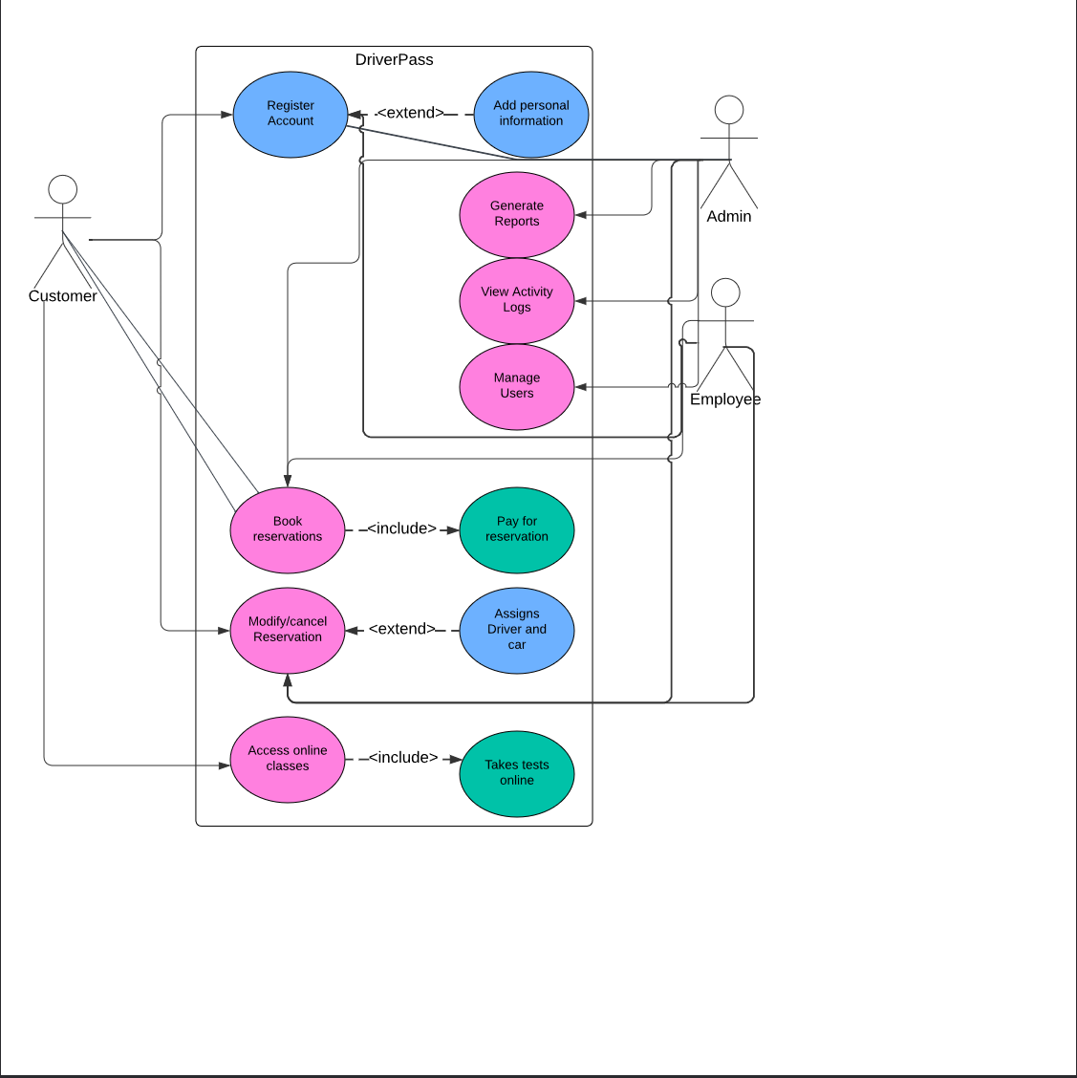

### UML Activity Diagrams

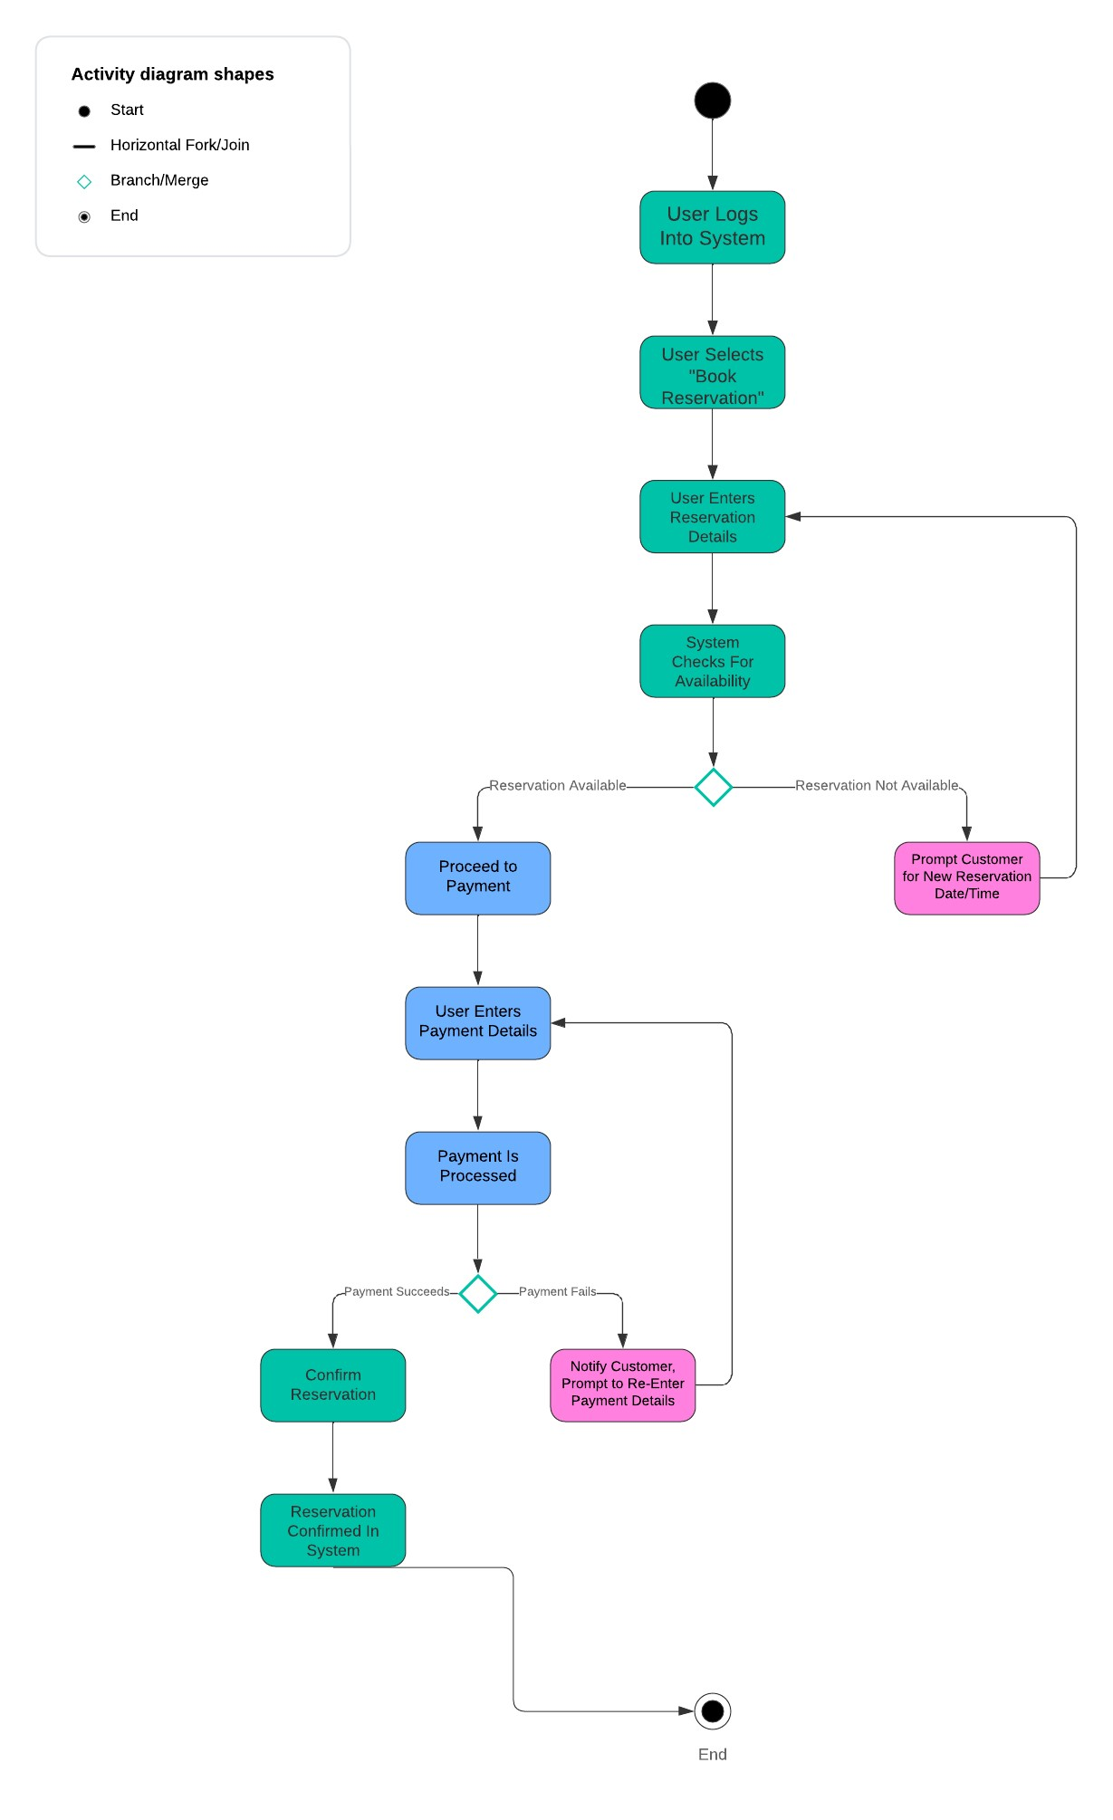

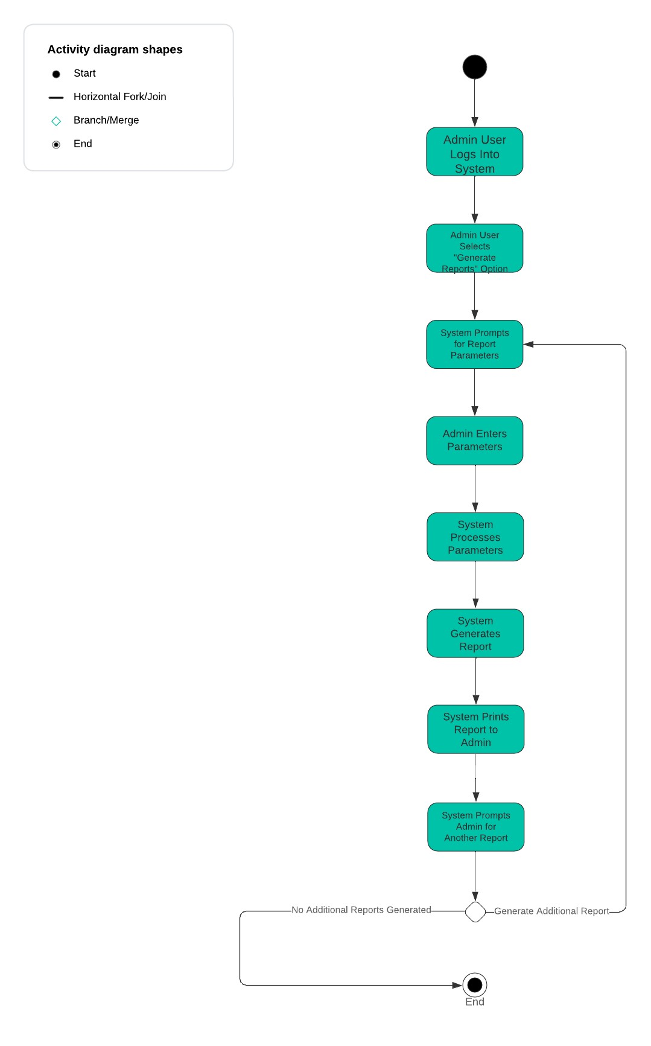

### UML Sequence Diagram

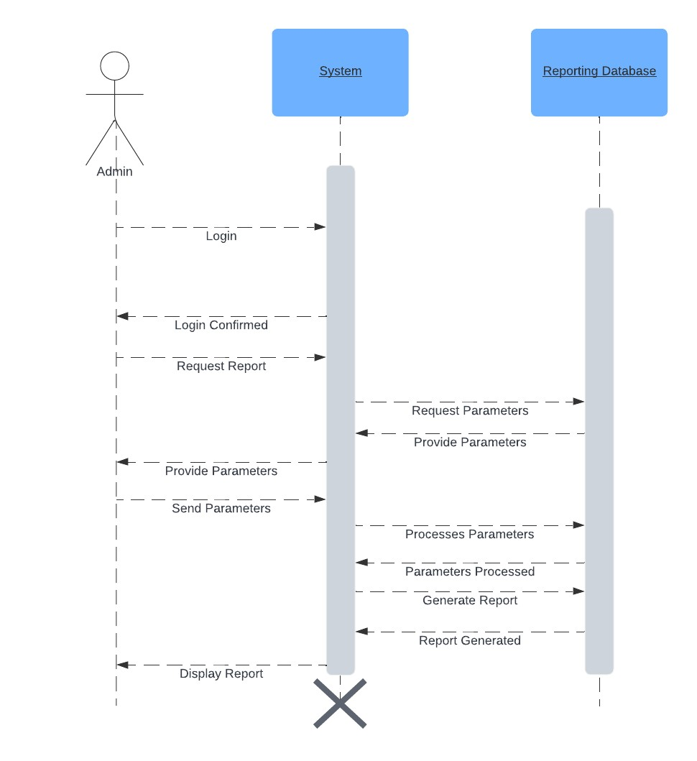

### UML Class Diagram

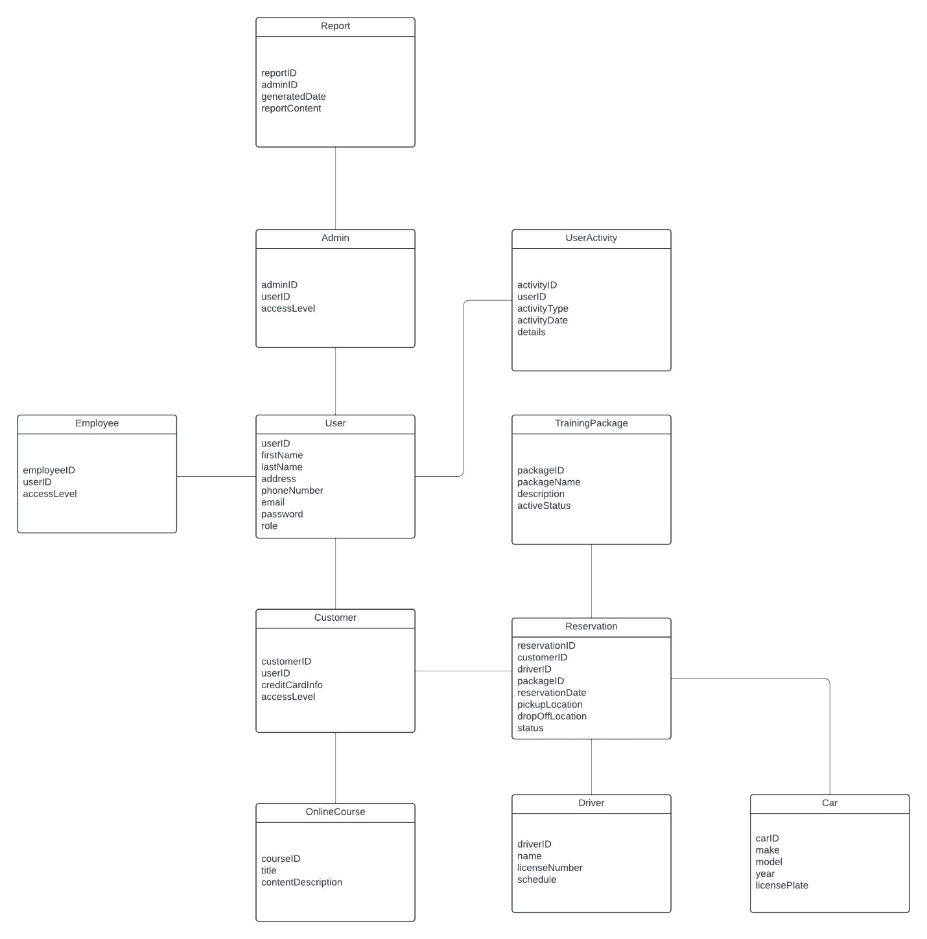

## Technical Requirements

The following are the hardware, software, tools, and infrastructure requirements necessary to support this system’s design:

1. Servers
   1. This system requires web-based servers that are reliable and consistently available for users to access. The system also requires a dedicated database server to handle database storage and operations
   2. Servers should have some sort of basic security encryption. (HTTPS)
   3. Database management system such as a MySQL server or Microsoft SQL server is recommended.
2. Devices
   1. Users require a device in order to access the system. This can be a desktop or laptop computer, or a mobile device. For employees and administrators, a laptop or desktop is recommended. Customers can use either a mobile device or computer to access the system. System should function on a variety of mobile devices and web browsers as this system will be web-based.
3. DMV Integration
   1. System must be integrated with DMV systems in order to maintain compliance with training materials and updated driving rules/procedures.
4. Payments
   1. System has to support a method for processing payments as payments are required from customers in order to book reservations.
5. Security
   1. HTTPS is recommended to support this web-based system. CAPTCHA and Two-Factor Authentication is recommended for securing account access.
6. Networking
   1. An internet connection is required for both servers and users as this system can only be accessed online.
7. Backup and Recovery
   1. Regular automated backups are required to be built into the server infrastructure for storage of critical information and as a precaution for system recover in the event of system failure.
8. Reports
   1. System should be able to generate reports at the request of an Admin level user. Reports should be able to track a variety of things like User Activity, changes to reservations, transactions, and etc.